First draft 2026 (V 0.5.2)

CC BY-NC-SA 4.0

I don’t know much about licensing but this is intended to be shared and collaborated upon. Copyright it used with intent to prevent others from copyrighting it or misusing it for profit. This exists as prior work.

Download the low quality beta version of the app for digital symbols:
https://drive.google.com/file/d/1zJ3RE091ETfdThXuBIGRlYWEEqshXgH5/view?usp=drive_link

Direct suggestions, criticism, or questions to:
NathanDarker1995@zoho.com

Or offer me an ALU-Card in passing.

Soul

Nathan Darker
Contents

Preface 5

Part One
Theory of Soul 7
1 Philosophy of Self 11
2 Theology of Self 15
3 Love of Self 17

Part Two
Symbolism 21
1 Emotions of Self 22
2 Needs of Self 25
3 Spirit 27
4 Mind 31
5 Body 32

Part Three
Vampirism 33
1 Vampirism 34
2 Truth Table 38
3 ALU-Card 46

Preface

This booklet describes a psychological tool which I wish I had as a child. It is intended to offers direction to those who don’t yet know their Self, and power to those who do. A good metaphor is the 26 letters of the English Alphabet. It is a system of symbology that tries to break the soul down into standardized and rigid fundamental pieces that can be used to communicate complex ideas. The illiterate will create nonsense, but some will create poetry.

The APA Dictionary currently offers a vague description of Soul while noting that scientists ignore or reject the concept due to a lack of an empirically verifiable definition. This is intended to become the solution.

What’s unique about the author is that I’ve been atheist, non-spiritual, and non-superstitious up until age 29. Additionally I had no interest in magick or anything but science and psychology. I was alexithymic (unemotional) and Computer Engineering was a soulless hobby of mine. But in 2024 I had a numinous spiritual awakening, and what I try to do here is use the insight gained from that to demystify mysticism. Starting with the soul.
Part One
Soul¹

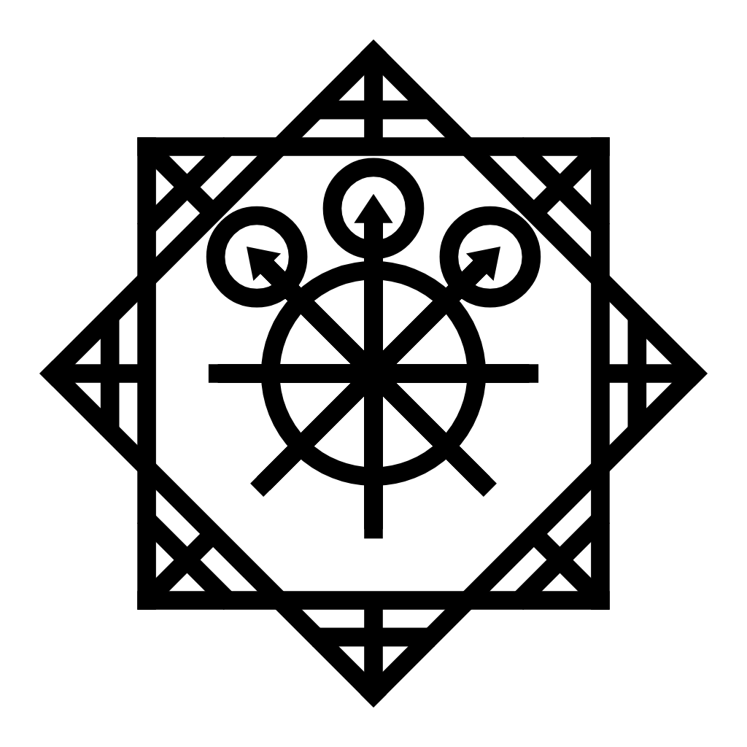
Soul
Introduction
This document is in its draft phase, so claims won’t be properly cited and supported before sharing. Instead the goal is to outline the current understanding as a functional proof of concept. The model is reverse-engineered from a top-down approach down to its most fundamental layer of abstraction. This is a Black-Box model where only Neuroscience can explain what goes on inside.
A good initial metaphor might be a Hardware Abstraction Layer in Computer Science; the point where neurons & transistors translate to abstract emotions & software.

This is based on my own understanding rather than derived directly from the works of philosophers. There are a few main philosophers that seem to understand things how I do but they have very different works. So I reference Carl Jung for the spiritual side of things, and Thomas Aquinas for the Supernatural & Theological side of things. Both can be tied to objective science.

Due to its divisive nature, religion is held at a distance and intentionally left agnostic. This document is dedicated to science and the pursuit of unbiased truth.

The topic of “magick” will be touched upon in a scientific manner, defined simply as “obscure psychology.” We may come to recognize magick to be something as innocent as the contagious nature of a yawn. For those who are opposed to magick, please take note that this document is anti-magick in design. It aims to uncover truths and make things less obscure.

Overview
The human soul has been a topic of debate for a long time. This chapter offers a detailed model that is loosely organized like Plato’s Tripartite Soul³, but with a more modern interpretation of each part. The three parts are: Self, Spirit, and Avatar. Here’s a brief overview:

The Self is the same as Carl Jung’s concept of Self, but with a more precise definition that can be thought of as emotion. It is an informational concept that functions to translate Needs into Emotions, which may sound simple but is a very deep topic. The Self is the most important part of a Soul because it is where all purpose and meaning is sourced from. All sentient life has the same Self (more or less). It is what separates us from machines and nihilistic reproductive entities like Jellyfish, Bacteriophage, and modern A.I.
In (outdated) Freudian Psychology, the Self is closest to the Impulse Drive. Or in Plato’s ancient Theory of Soul, it is closest to the Thymoeides. To us, it’s Needs & Emotions. More on this later.

The Spirit is a mixture of Ego and Shadow in Jungian Psychology. It is a collection of individual experiences that give context to new experiences. The spirit houses our personality and makes us unique. The spirit changes over time and can even be transferred out of the body in forms like an autobiography. A Spirit that is not attached to a Soul can be considered a Ghost (scientifically speaking).
In (outdated) Freudian Psychology, the Spirit is closest to the SuperEgo. Or in Plato’s ancient Theory of Soul, it has no solid counterpart but exists between the Logistikon and the Thymoeides.

The Avatar is a singular word for Body and Mind. It is where the center of consciousness resides (in my model), and is also the physical portion of a body. A good analogy from Computer Science is the hardware of a computer (body) but a focus on the CPU (center of consciousness). While everything gets emotional appraisal from the Self, and personality lives in the Spirit, everything else is in the Avatar. From the fight/flight response, to sexual arousal, to somatic feelings, the 5 senses, and so on.
The Body is relatively straightforward to create symbolism for, but the Mind is a bit unclear as of now.
The Avatar is the only physical element of the Soul, but is also informational (like a CPU) and generally Fungible in function on the species level.

Something like a Traumatic Brain Injury’s disabling effects on cognition would be symbolically represented in the Avatar. But something like a Personality Disorder would likely be represented as relation between Spirit, and Mind. In relation to thoughts, the Self emotionally appraises information while the Mind logically processes information (in the same neutral way a CPU does). The Spirit is a bit like a hard drive that stores information such as feelings and beliefs that funnel through the Mind/CPU.

Collectively the Self, Spirit, and Avatar create a Soul. The word ‘Avatar’ is slightly more future-proof than Body considering that Artificial Intelligence will likely develop a Self, Spirit, and Mind… but be hosted within a computer rather than a human body. That computer is A.I.’s Avatar, and it will be able to switch avatars where only the Self and Spirit remain the same.

Identity
An interesting philosophical topic is how our human -identity- is most permanently tied to our Avatar with a hardwired fear of death. It relates to a Sci-Fi topic (Mind Uploading) where either the Mind or the Body must experience continuity in order to escape perception of death. For example, when we sleep our consciousness shuts off while our body remains the same. But if our consciousness shuts off while an exact copy of it wakes up in a different body (and the old body dies), that’s just dying while a clone lives on. This is much different than sleeping and waking up, and that is because there is no continuity between one of the two avatar elements.

In the mind-uploading concept, you are transferring your Spirit from a Flesh-Avatar to a Digital-Avatar. In order to avoid perception of death and be considered a transfer instead of a clone, you would need to experience dual-consciousness. Like seeing through two eyes at once with both -minds- synchronized between them as one. Then one eye shuts forever, the flesh-avatar dies while the digital-avatar experiences the last moment of the flesh-avatar. The Mind is what experiences continuity in that scenario, thus escaping perception of death (ironically by experiencing it). Anything else is just cloning while the old body dies.

This is all hypothetical to bring the idea of identity into question. Suppose in a mind-uploading scenario, the old body goes into a coma (instead of dying) and wakes up 5 years later? Who’s more “authentic” then? The old avatar or the avatar with 5 more additional years of memories and experiences?

Our Spirit makes us unique but changes over time. Our Avatars are naturally tied to identity through fear of death, and our Self is much more permanent.
Philosophy
At the core of a Soul is the Self. It is important to talk about the top-down philosophy of Self before getting into the symbology. This will be explained in the way I have come to realize it.

There are people in the world that believe logic is superior to emotion and that emotion is weakness. That was me at a young age. I made the mistake of trying to suppress -all- of my emotions, leading to an alexithymic disconnection from emotions and a false sense of cold intellectual superiority because of it. Eventually I had to ask myself:

What is the purpose of life without emotion?

I applied reductive reasoning to every idea I had of what life’s purpose might be. This was metaphorically like picking up a rope (from the ego) and following it one hand at a time toward its end (i.e., systematically plucking away the ego). I recursively asked -why- something mattered to break it down to a more fundamental reason -why-. Surely the source of all purpose would be at the end of the ropes. Life’s core reason -why- would be there, why wouldn’t it be?

At the end of every rope was nothing, there was no justification for anything. Like reaching for more rope but only to feel the empty void of Existential Nihilism. I felt (almost) no emotion, valued no emotion, and came to the undeniable logical conclusion that Existential Nihilism is reality. There is no purpose to life, and life or death matters no more than the color or shape of any random speck of dust (Game over!). As a matter of fact there was no logical reason to do (or not do) anything at all. But how could that be if things clearly matter so much to nearly everyone (including me)?

I was mentally standing at the edge of the Nihilistic Void and I could feel something inside wishing it weren’t true. -Why- did I wish it weren’t true​? I didn’t know it yet but that was my soul (the Self) trying to abolish nihilism. The other end of the rope had Emotions as an equally undeniable yet conflicting answer. Emotions provide life’s core reason -why-.

This made me stop rejecting emotions and instead view them as the meaning of life. I believed emotions were a lie (against nihilism), but a lie we are all hard wired to believe and experience as qualia. I called it The Illusion of Life at the time. There is no logic in anything but accepting the illusion of life as reality. Positive emotions are easy to avoid, but negative ones are pretty hard to escape by avoiding them. In short, Nihilism is reality but Emotions overrule it with no objection from Nihilism. This effectively abolishes Nihilism.

I’ve boiled the core of that down to a philosophical argument (it may need work):

Premise 1
In absence of emotional (or religious) considerations, the application of reductive reasoning to any sense of purpose results in Existential Nihilism.
Premise 2
All sentient life experiences qualia of Good and Bad, abstractly known as emotion.
Conclusion
Emotions are -at- the source of all purpose.

Religious considerations are removed so that it holds true for atheists and theologians in the same manner. This links both sides to a scientific understanding, which we’ll link to theology on page 15. It should not be interpreted as a rejection of religion but a way to get all minds to the same borderline between emotion and the existential void.

Moving on from that, I had always considered myself science-grounded, atheist, nonspiritual, and non-superstitious. But many years down the road I experienced a Spiritual Awakening (there are many kinds). The way I understand Spiritual Awakening boils down to a purging of Jungian Ego & Shadow, but also un-repression of emotions if they’re repressed. This leads to an unfiltered and raw experience of the Jungian-Self, like finally experiencing emotions clearly. As if you’ve metaphorically been drunk all your life and the beer goggles are off. This often occurs partially, leaving us blind when it comes to other emotions. Overall it works toward what Carl Jung calls Individuation, where we are increasingly Self aware.

To recognize the Self clearly and -identify- with it is to see your Self in others and identify with them too. In a way, I am everyone else and everyone else is me. That is because we all have the same Self, but different stories (i.e. Spirits) and bodies (i.e. Avatars). This may sound “woo woo” on paper but to believe it as qualia is a beautiful -experience- that seems to require a spiritual awakening.

Mirror neurons play a big role in turning this to a lived experience of interconnectedness (i.e., empathy).

The main point is that Emotions are at the source of all purpose, and the source of what makes us all the same in spirituality. So what causes emotions? Survival Needs cause emotions, depending on whether they’re met or unmet. A lack of met needs can result in emotions.

I make the declaration:

The Self is the informational conversion of Needs into Emotions.

That is a simple definition but it is very profound when you look at what happens between Needs and Emotions. There are three elements at play. The input (i.e., Survival Needs), the appraisal (i.e., The Jungian Collective Unconscious), and the output (i.e., Emotions). It is easiest to recognize the Self by its output (i.e., emotions), but the most profound and important part to grasp is the -source- of appraisal. It’s somehow coded into our DNA through evolution in such a way that everyone (even animals) understand it in the same general way. As if nature created a Look Up Table (computing term) through evolutionary Machine Learning. Abstract information about our -needs- go in, and emotions come out. Emotion is the direct language of the soul, universal to all sentient life as the source of all meaning. It comes from the Self.

I haven’t come across anyone else who has defined the Self like this. Many talk about it and say it is unobservable, which seems true if trying to observe the middle element of -appraisal-. So this is entirely my model of Self, which I model as a black-box using reputable psychology resources such as Maslow’s Hierarchy of Needs & Plutchick’s Wheel of Emotion. Finally we have a starting point for symbolic design.

Before that we will touch on theology to look past emotion and into the -source- of emotion. I will remain scientifically grounded in doing so, but the theological link is in the Collective Unconscious. The source of all shared meaning.
Theology
If we take Self to be the conversion of Needs to Emotions, the Self becomes an interesting single-argument to some philosophical and theological problems.

There is a philosophical problem called the Euthyphero Dilemma which asks:

“Does god will it because it is good & just, or is it good & just because god wills it?” – Plato

We can retain the same meaning while removing theology by using Self to scientifically represent a primitive and heuristic form of God’s Will:

“Does emotion will it because it is needed, or is it needed because emotion wills it?” – Plato

This draws attention to what lies between Needs and Emotions both in the scientific version, and perhaps in the theological version too.

I suggest that between Needs & Emotions lies evolution, neuroscience, divinity, and Carl Jung’s Collective-Unconscious. All existing in parallel. It does not matter which one you believe in because it does the same thing in effect and therefore they are all the same when it comes to the Self. In other words this is where Science and God meet. The source of -all- purpose.

Compare premise 1 & 2 (three pages back) to Abrahamic Creation Story’s concept of Darkness and Light (which -is- good). When viewed in a strictly scientific manner it fits as a metaphor. That is not to suggest it’s the only possible interpretation, but it is a uniquely science & psychology grounded one that -can- be experienced.

There is another important problem in Theology called Hume’s’ Guillotine. It is meant to draw attention to how values are derived from facts in order to shoot down illogical assumptions. However it is strangely conquered when the Self is an argument. Again, it draws attention to how Evolution and/or God coded the logic that translates Needs to Emotions. It is the explicit job of the Self to derive values from facts.

Lastly, let’s look at a quote by Thomas Aquinas, a Catholic Philosopher who took Plato’s concept of Natural Law (grounded by the Self) and connected it to the concept of God’s Plan (i.e., Eternal Law).

“the rational creature is subject to Divine providence in the most excellent way, in so far as it partakes of a share of providence, by being provident both for itself and for others. Wherefore it has a share of the Eternal Reason, whereby it has a natural inclination to its proper act and end: and this participation of the Eternal Law in the rational creature is called the Natural Law”

Natural Law is still a philosophy topic today but is said to lack “grounding.” That grounding would seem to be the Self. I believe Rule-Utilitarianism is how Self-Grounded Natural Law Theory would be able to unpack the heuristic emotional form of God’s Will, into Human Law described by words.

Lastly, Aquinas laid down what he called the Five Ways of proving the existence of God. All Five Ways appear to exist between Needs & Emotions in terms of evolution and time. The Collective Unconscious holds a memory developed over time, akin to Nietzsche’s Will to Power (to survive).
On a side note about Nietzsche, he was an early modern-philosopher who seems to have gone down a similar path as I have as an emotion-detached psychonaut of the mind. I don’t know much about him but do believe his Will to Power was an incomplete perspective working toward the concept of Self. If I had to guess, he avoided sorrow instead of leaning into it. So he bottled up a -ton- and was not able to handle it when the psychological dam broke in the face of the turing horse (the trigger). This seems to be an example of the importance of being able to view the Self without distortions by embracing emotion and working toward individuation. You can get close in ways that seem to make sense, but miss the point. You can’t escape emotion, you can only detatch from benefitting from it. As it bottles up it clouds your judgement and perceptions often without being felt.

Love
In theology, it is often said that God -is- Love. If you look up the highest form of Love it is Agape Love (i.e., unconditional love for all). In theology, Agape Love is said to be God’s Will. Atheistically we can generally agree that Love is good. So what is Love anyway?

At its core, Love is Soul Care; Love takes care of the -needs- of souls. The word itself is polysemic and means a lot of different things (as parts of the whole), but Soul Care is the single unifying definition that links it all together. That definition is a unifying and organizing backbone for any definition you may find. With that you can start to develop a hierarchy, but I’ve gone ahead and started this.

Before digging into that hierarchy, I’ll mention that Evil is “Love which violates Love”, meaning needs are met at the expense of other needs. Not all Evil is unethical, but it is ethical to minimize evil as much as possible. Eating spicy food is a simple example of an ethical evil. Accepting pain for flavor in this way is not immoral if consensual. On the other hand, torturing someone (without consent) with spicy peppers is Evil that is unethical. That is because it violates their needs, and violates Agape Love. I may be wrong but the difference between Evil and Sin is that Sin -always- Violates Agape Love, while Evil doesn’t. Whether you mean it in a theological or atheistic sense, I define Sin as a word meaning “to miss the mark” where the mark is Agape Love (i.e., Love for all). These are two fundamental “rules” in definition form, for a rule-utilitarian perspective of Love.

The most basic form of Love is Self Love. When a soul meets its own needs. Evil can happen at this level. Smoking a cigarette is an easy everyday example. Take note that needs are -inputs- and emotions are -outputs-, so the Self is a -cyclical- engine of Love that continually tries to feed itself (generally toward survival and connection).

The next level of Love is social. When a soul meets the needs of another. This is often mutually beneficial due to mirror neurons and the evolutionary way the Self developed emotions. But teamwork also works here too. Social Love is often (but not always) mutual Self Love. Social Love is Evil when the needs of one soul(s) are sacrificed for the needs of another soul(s).

There is a higher tier of Community Love, which is more like a system of -bonds- that are generally less personal than individual-level bonds. The greeks pinned down 8 types of Love which can help classify types of Love-Bonds. Some of these are Storgic (family & childhood friends), Philia (friendship), Ludus (play & touch), Eros (sexual), and of course Agape Love.
There are also some studies and work done on tiers of friendship and how many hours are generally needed to reach each tier (acquaintance, casual, close, and intimate) but I place a more fundamental focus on -what- exactly a bond is made of. It’s far more useful to know exactly what a bond is made of so that we can give words to what we want and/or feel is missing.

In general I find that Triangular Love Theory illustrates three core components in a Love Bond. Although it was designed for Romantic Relationships, it can be repurposed as a platonic diagram.

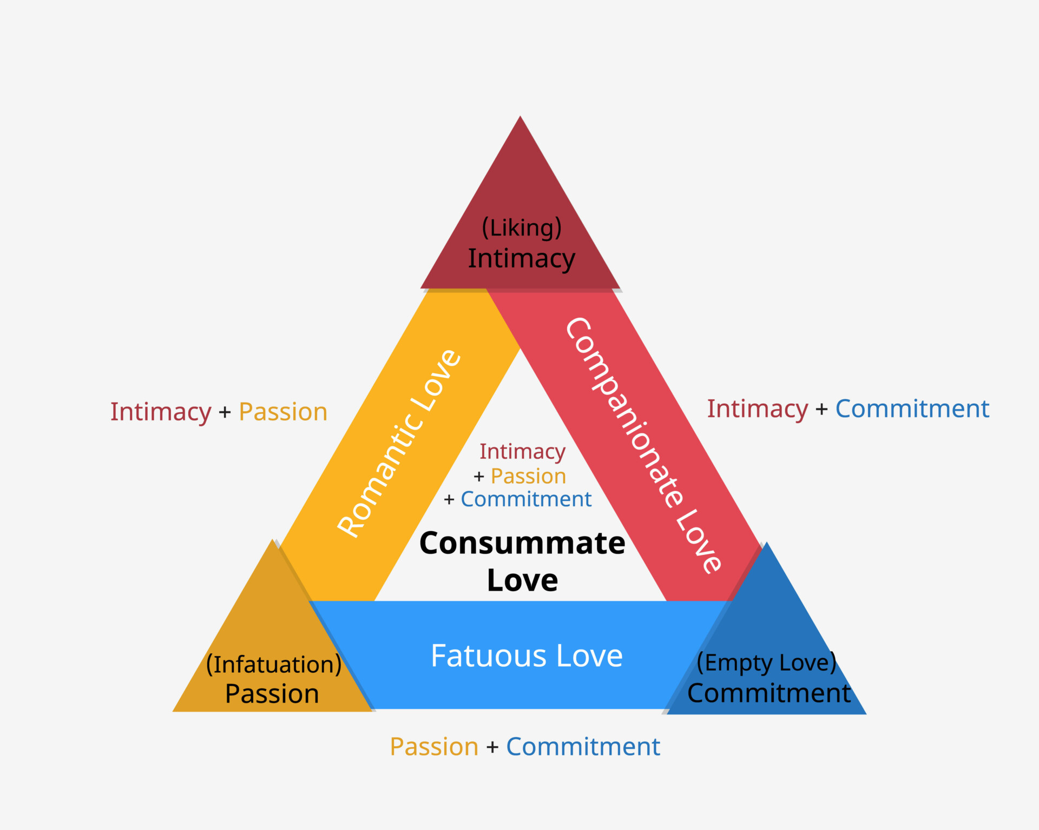
If Passion is replaced with Self/Emotion, and Intimacy is replaced with Spirit, then Commitment is replaced with Avatar. Where Fun happens in relation to the Self, deep connection happens through intertwining of the Spirits, and the logistical side of things happens through actions of the Avatar. This chart is useful to identify what is lacking in a Love Bond, especially with individuals who “lack a sense of self (i.e. spirit)” and don’t have a stable Spirit to identify with and share to others.

Many people refer to the 7 Love Languages when asked what Love is, but I find that many of those 7 languages are falsifiable and only guarantee the “Empty Love” category. This can really sting in some love bonds like Storge where there is a reasonable expectation (and need) for more. This is a solid example where -nothing- (lack of action) is an invisible form of psychological violence, further hidden by things like artificial harmony where lovelessness looks like love. This is a very specific example because it’s one I know, and all parties involved never knew better. When we haven’t fully experienced Love we are blind to what it is and should be, and tend to pass that blindness down generationally. It is that Intimacy element (merging spirits) that seems less common.

On a side note, Bromance (as I know it between heterosexual dudes) is the original Triangular Love Theory but as an exaggerated joke that edges and/or pushes the line of discomfort with an underlying and legitimately strong platonic bond as a foundation of trust. The stronger the bro-bond, the more over-the-top the bromance.

At the very highest tier of Love is Agape Love. Love for all. This is definable concisely as love that -minimizes- evil and -maximizes- joy without sin. Impartially maximizing the good while minimizing the bad. This gets very complex when applied to controversial situations and requires a way to mathematically quantify things.
Theologians make the claim that only god is all-knowing and can make perfect judgment, and so long ago I made the utilitarian rule that on the individual level it is okay to make mistakes so long as you made the best judgment you could with the information you had at the time. It is not possible to be perfect, and so we must keep that in mind with the personal judgments we make.

Long ago while thinking about Rule Utilitarianism, I came to the conclusion that it was sinful to spend so much time thinking about morality on the grounds that it wouldn’t matter if I had all the answers because who would listen. It robs me of my time with no real payoff and was therefore evil compared to trying to live my life in the moment. On top of that, what use is it to be the most moral dude in a world of immoral people?
Many years later I find myself revisiting that thought with the new perspective that ethical know-how is empowering in conflict (which is everywhere), and so I’m making and sharing this document.

To recap: Emotion truly is our source of purpose. The Self is the soul’s compass, and Agape Love is what it points to. That is the direction I request people work toward.
Part Two
Symbolism

Emotions
The best model of fundamental human emotions appears to be Plutchick’s Wheel of Emotion. It outlines eight -primary- emotions in which all others are made. It is recommended to read about this model and each individual emotion’s role to gain a basic sense of Emotional Intelligence and familiarity with the model’s layout, as well as the role of each emotion plays in responding to needs.
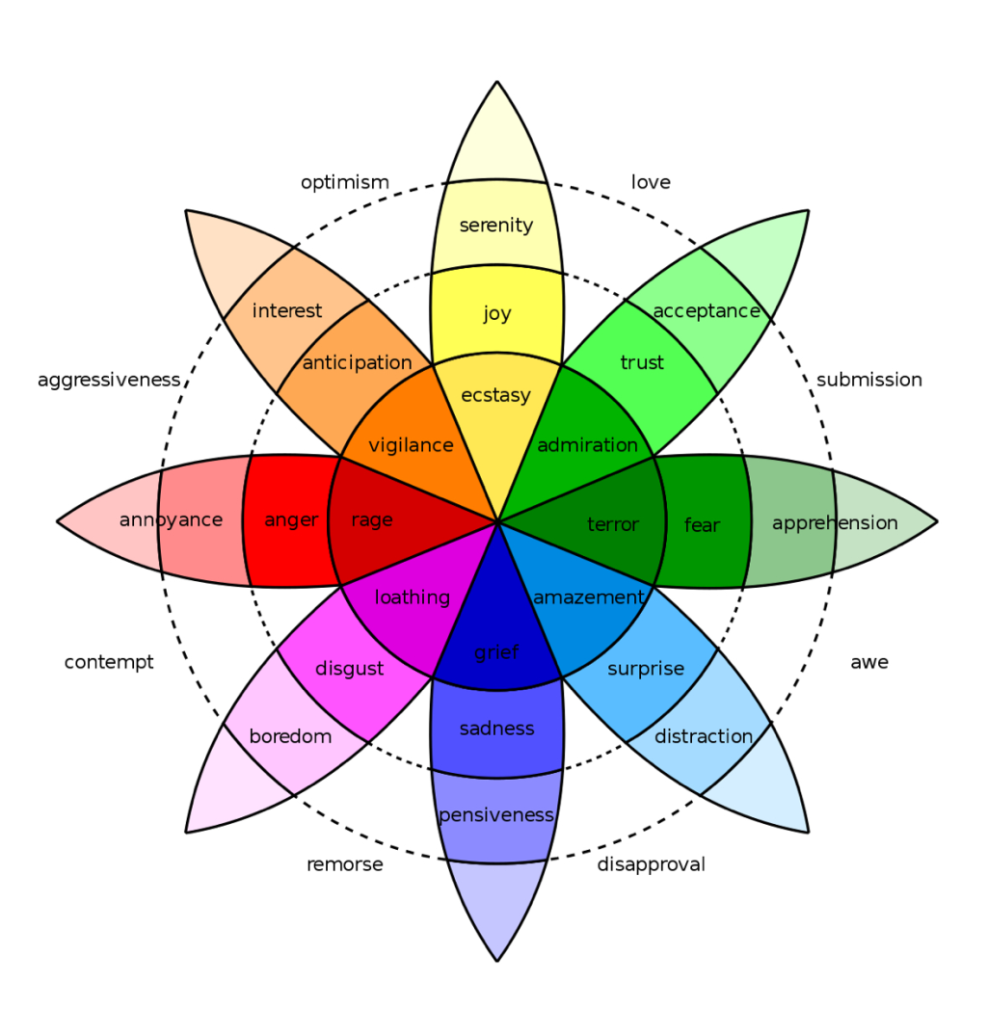
Plutchick’s Wheel lays the foundation of the symbology and gets represented by a minimalist and easily drawn eight pointed star (The Chaos Star). There are symbols drawn on each of the tips of the star to represent whether that emotion is: Expressed, Suppressed, or Repressed.

Emotional intensity is removed to simplify representation into a binary presence, and direction of emotion.
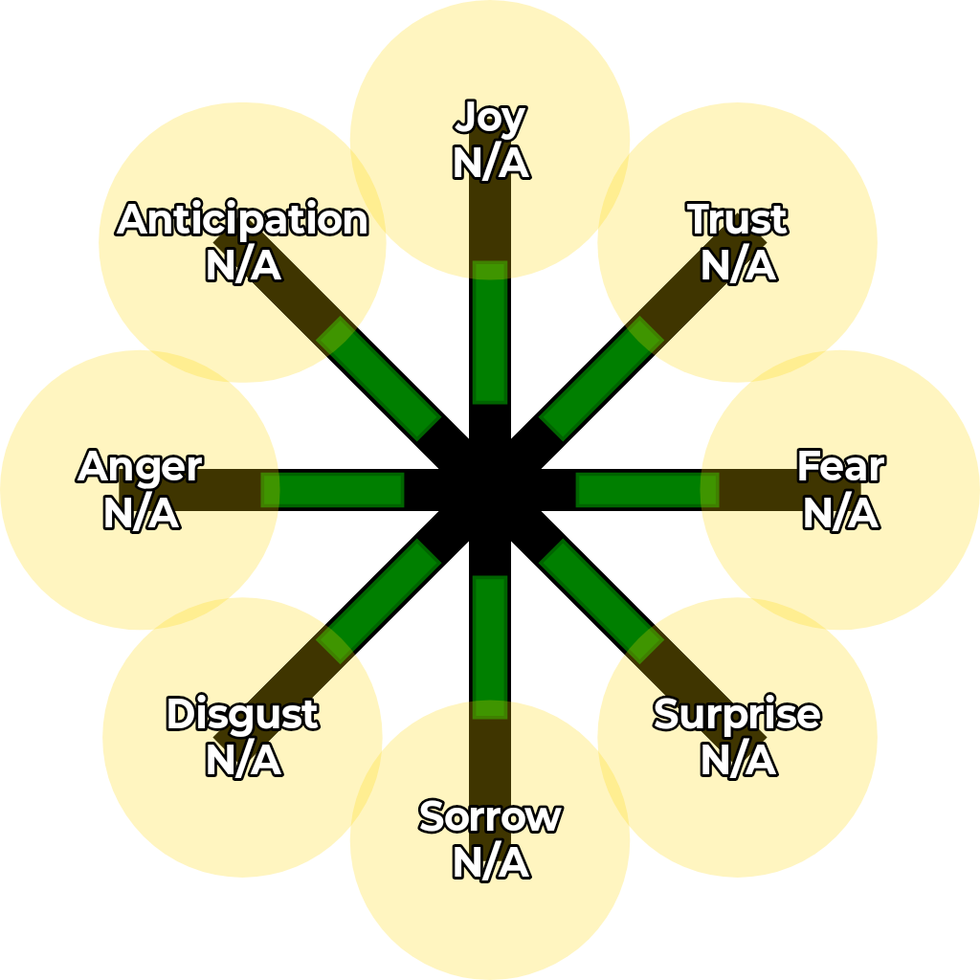
Below is a digitally drawn “legend” using an android app I’ve created to streamline digital production of these symbols. The highlighted circles show where emotions will be displayed, and the green-rectangles are irrelevant (for in-app use). Around the “tips” is the option to draw a circle to represent mirror-neuron activation. This is usually empathy but should not be assumed to be compassionate (although it usually is). Empathy works through mirror neurons, but neuroscience supports that narcissists have overactive mirror neurons which fail to be used for compassion. At the same time, empathy for sorrow can be masochistic in a masochistic individual, even if witnessing sorrow in a non-masochistic individual. So there is a difference between Cognitive Empathy, Affective empathy, Compassionate Empathy, and non-compassionate non-empathetic mirror-neuron activation. Entirely separate from Sympathy which is of the mind and -ought- to mirror empathy for situations empathy vanishes.

This is a nonsensical example with a matching legend.
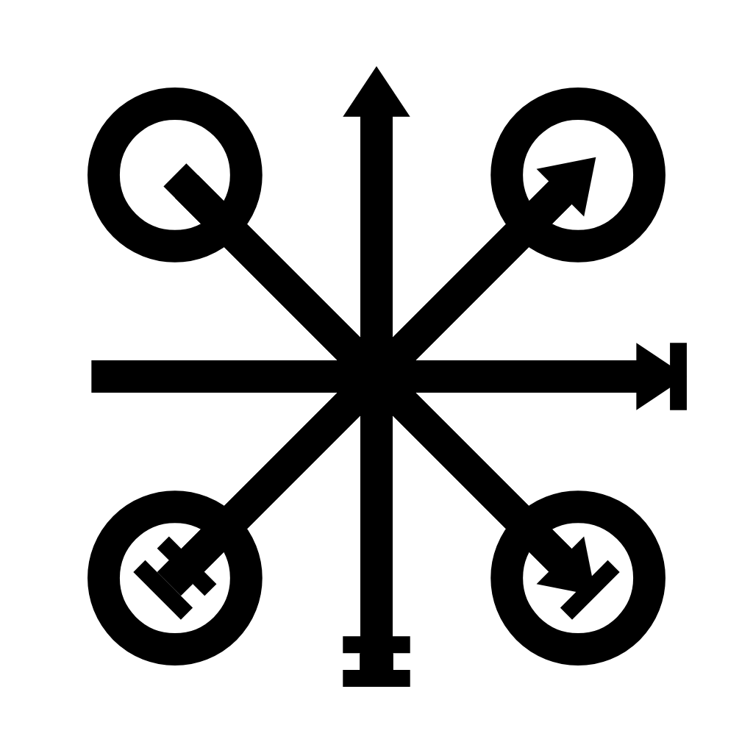
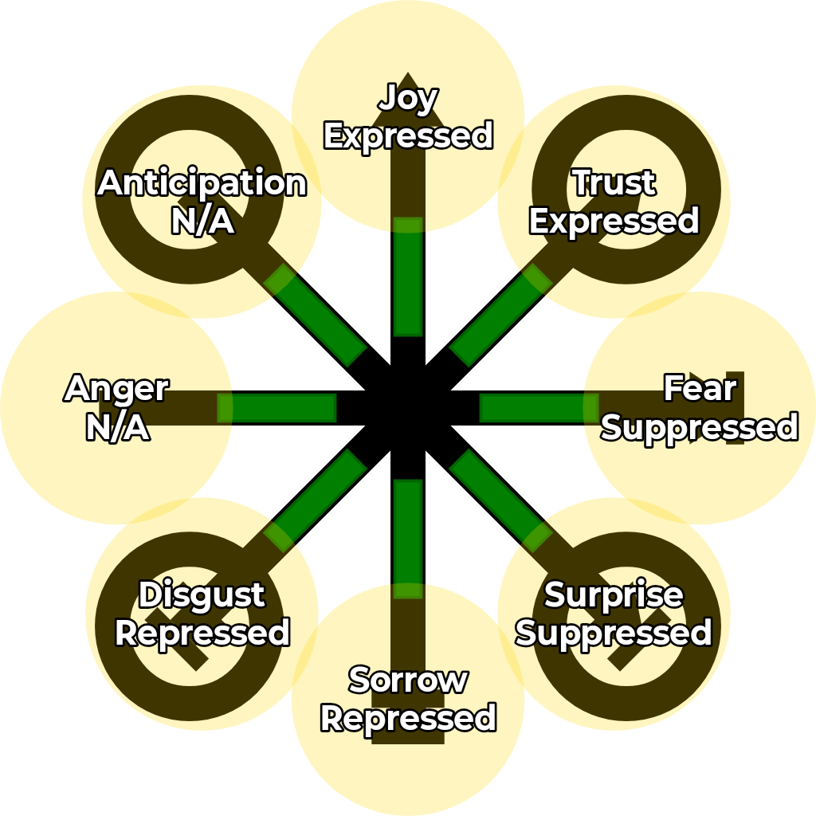
Needs
The most popular model for human needs is Maslow’s Hierarchy of Needs.
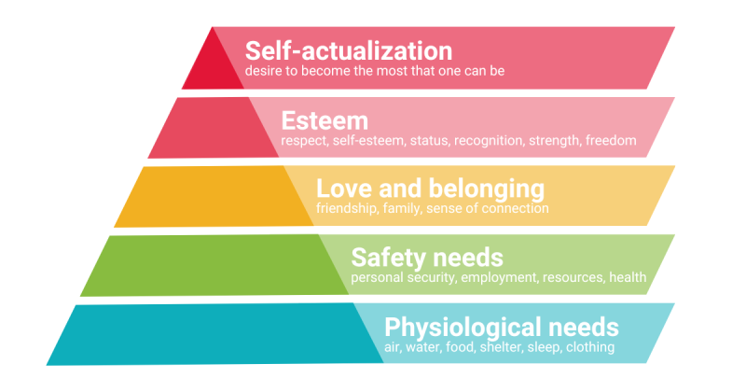
I removed the self-actualization need (yet to update images) because it is an abstraction of the other four needs, more precisely represented through this symbology later on.

The hierarchy of needs is mapped onto the star by using the 4 quadrants. They are relabeled but retain the same meaning. The hierarchical nature of these needs are implicitly retained but not directly represented. In terms of Rule Utilitarianism, the hierarchy is a solid way to prioritize needs in relation to ethics.

The needs are represented as either: irrelevant, met, or unmet. This pairing of needs and emotions effectively represents the Self.

On the next page is a legend, as well as what I believe would be a representation of experiencing Consummate Love & Compersion.
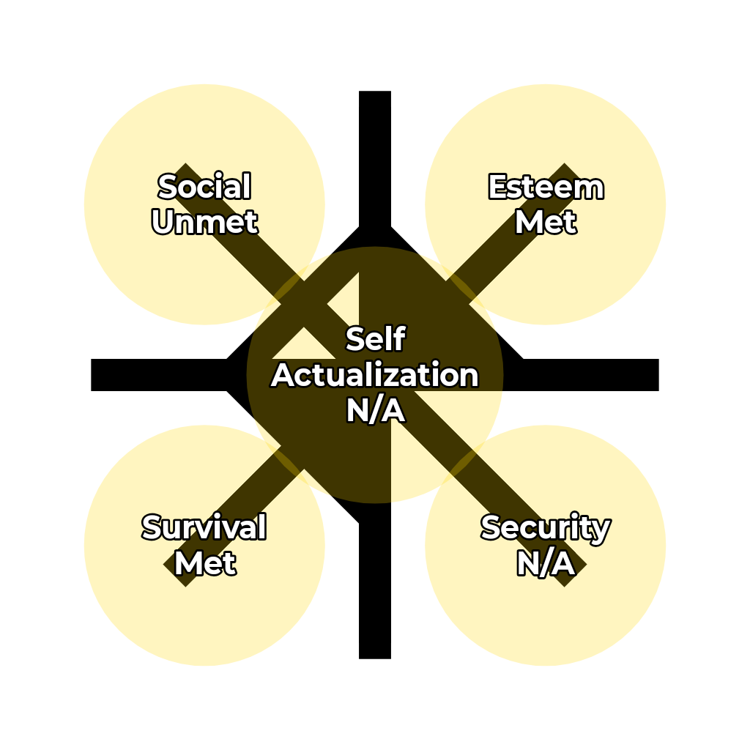
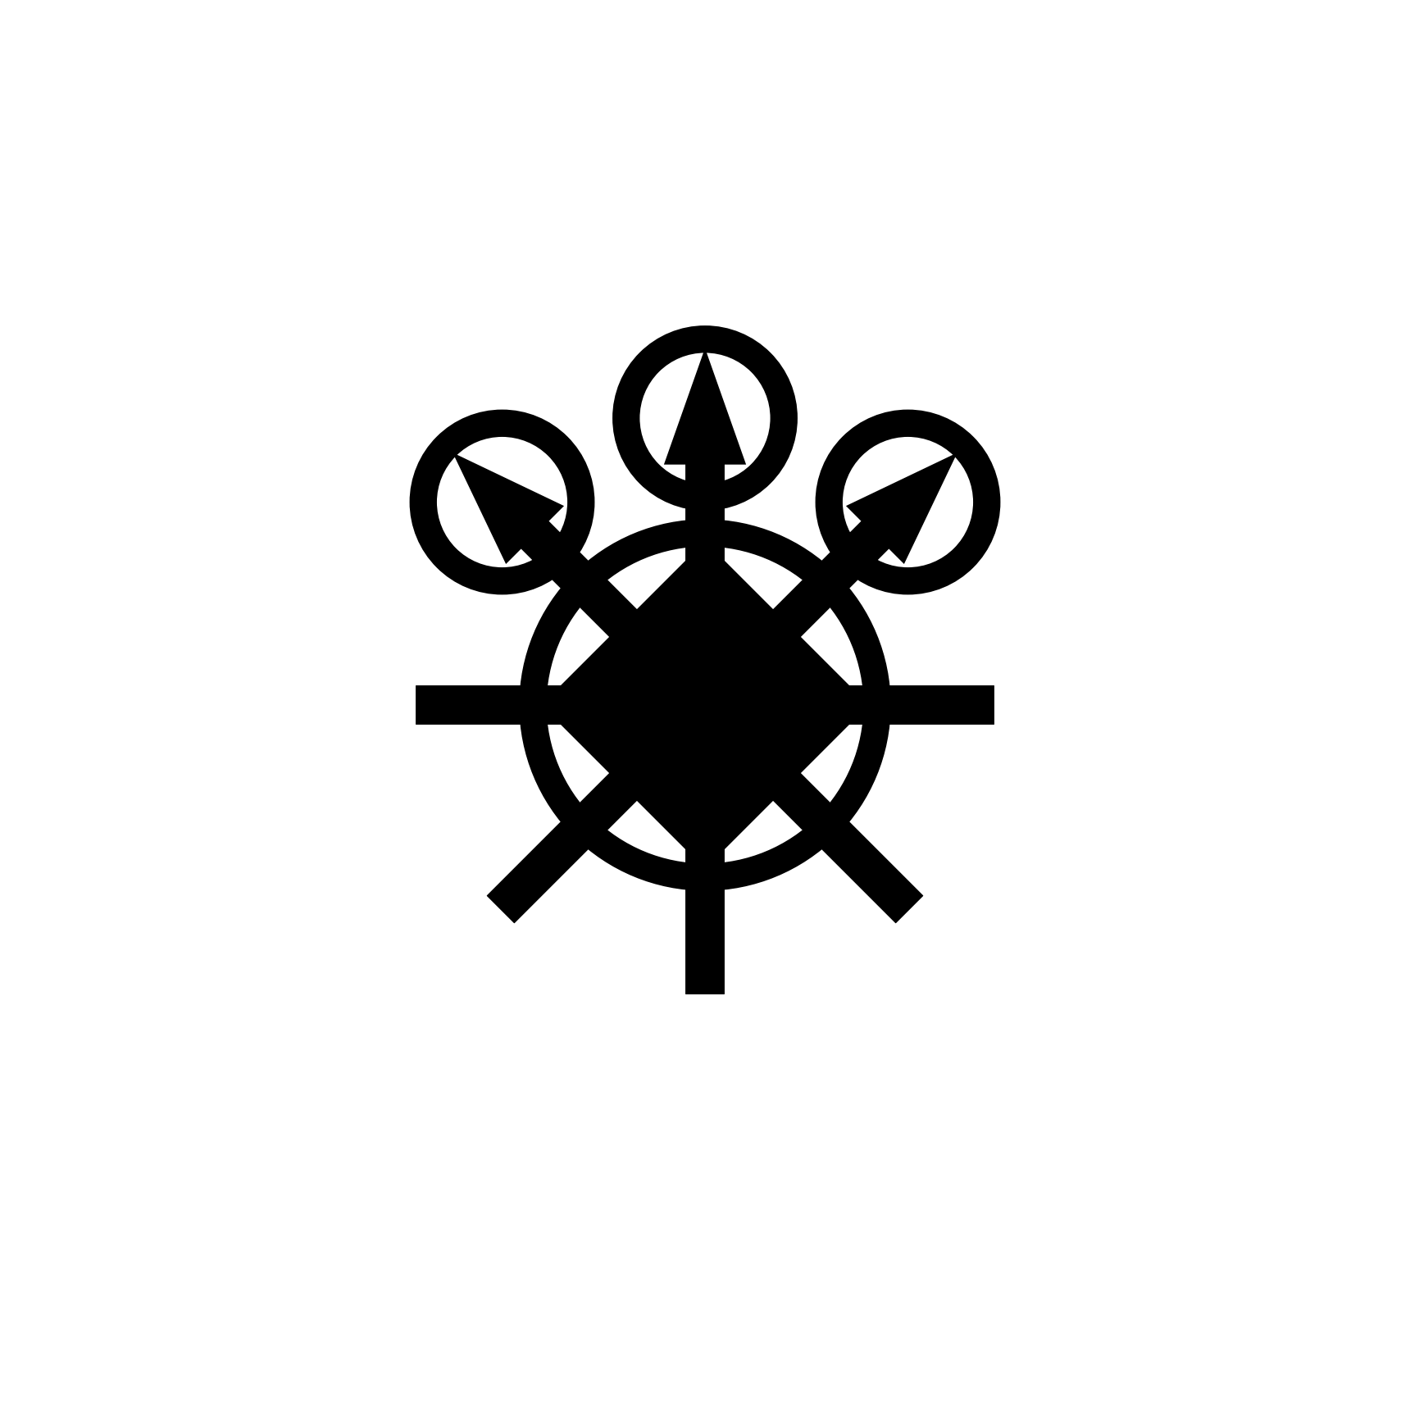
Spirit
Everyone has a Jungian Ego, like a narrative of past emotional experiences that give context to new emotional experiences. Some aspects of our Ego are unconscious and reside in our Shadow. Our Ego and Shadow become a sort of filter that turns objective experience of Self into subjective experience. Observe the similar structure of Carl Jung’s model and my own.
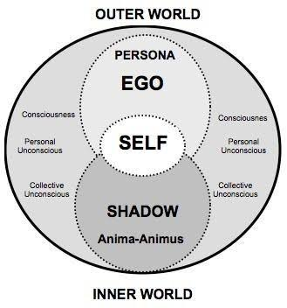
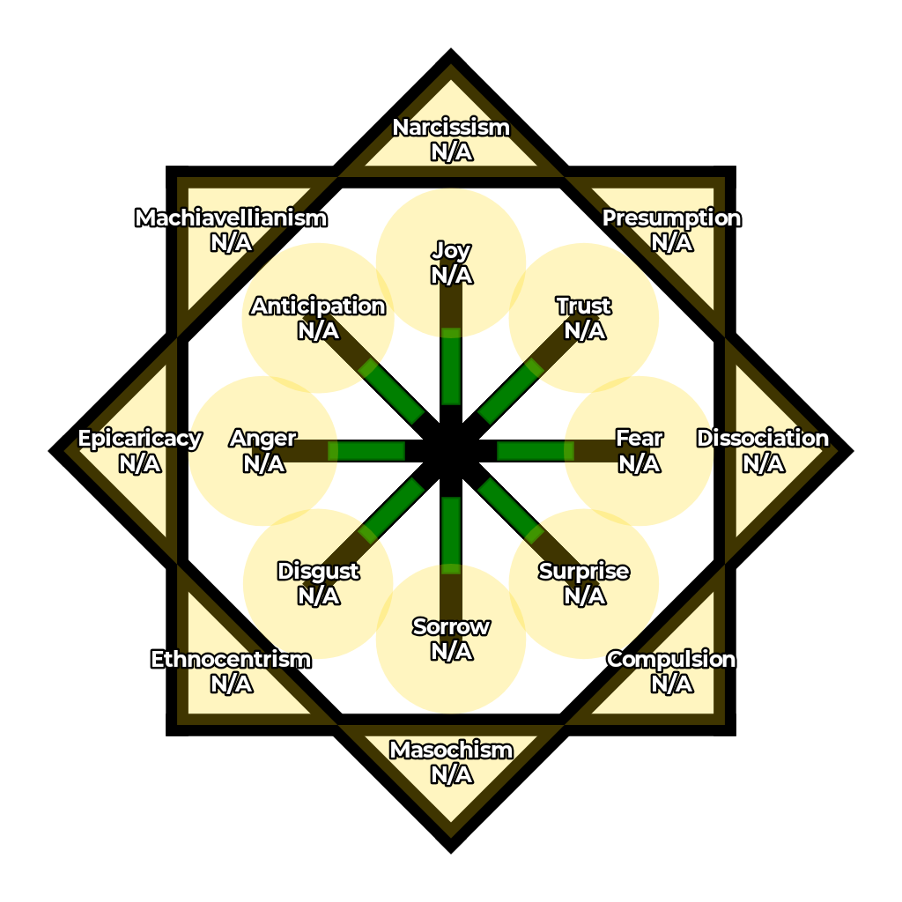
Each spirit aspect has the option to be in the Shadow (unconscious) or Ego (conscious).
At the Spirit level, emotions are also divided into inner-emotions (inside the spirit-star) and outer-emotions (outside the spirit star). This is useful to depict a difference between what is felt on the inside, and what is presented to the outer world (Jungian Persona). Additionally, the same circular symbol used to mark Empathy becomes Projection when circling outer emotions.
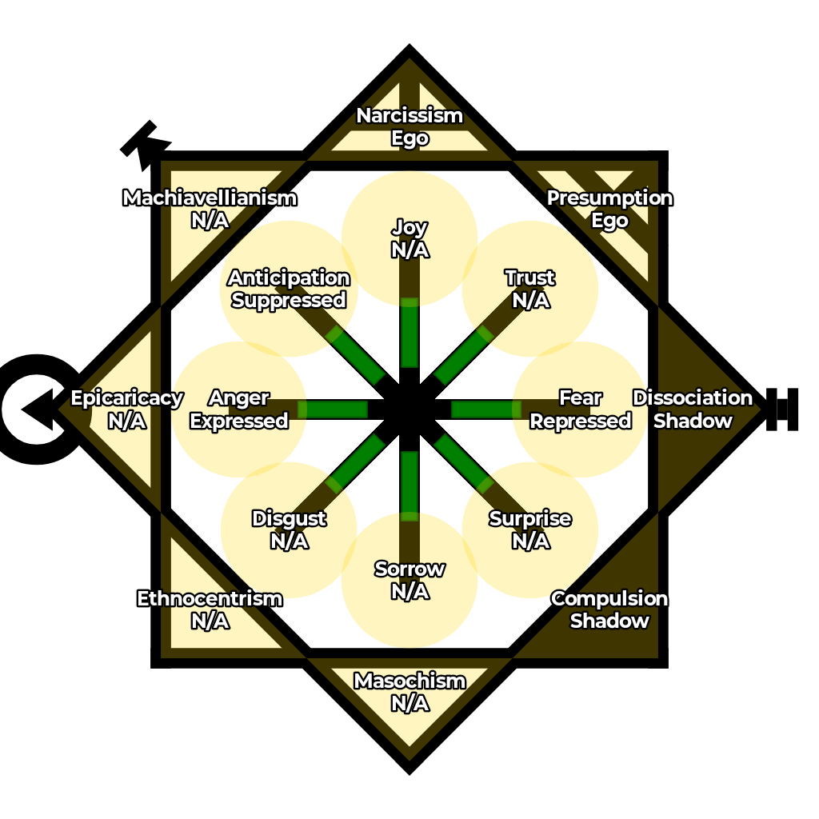
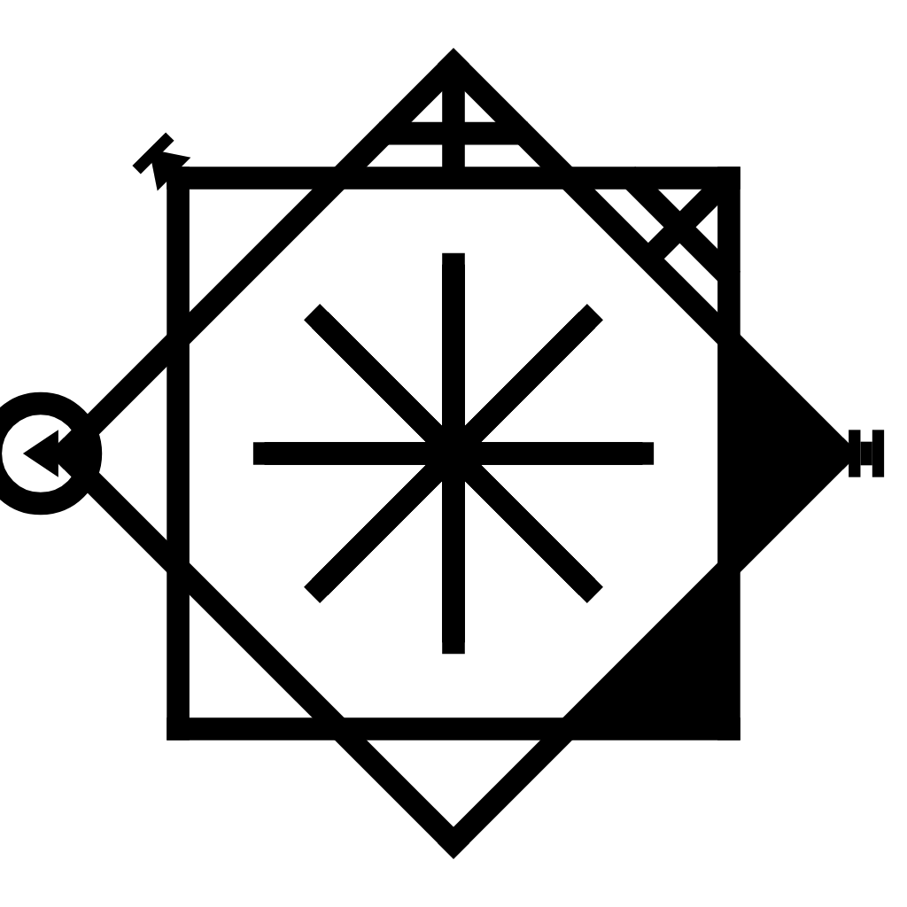
That example is a nonsensical one meant to show off all of the marking options. It is worth pointing out that each Spirit aspect correlates with an Emotion. Each label is meant to be an umbrella term for good or bad manifestations:
- Narcissism is Self Love. Healthy Narcissism is a thing, and unhealthy narcissism is too.
- Presumption & Ethnocentrism are both on what I call “the axis of prejudice”. I try to find the right words for every manifestation (good and bad).
- Dissociation was derived from the Dark Tetrad trait “psychopathy” and made more fundamental.
- Compulsion was derived from the idea of trauma, repetition compulsion, and OCD-like symptoms.
- Masochism represents the idea of enjoying sorrow (emotions are the focus).
- Epicaricacy was derived from Sadism to remove implications of sexuality, aggression, violence, and the inherent tie to -causing- harm.
- Machiavellianism is taken directly from the Dark Tetrad to represent a fixation on social power.

This becomes a detailed map of someone’s Spirit, and it may lack some important details as of yet but it is a solid starting point. I am currently interested in testing out how well this model of Spirit might function as a “progress bar” for Jungian Individuation. Both for guiding the unrepression of emotions, but also for guiding shadow work.

Below is a debatable example of an ideal spirit. That compassionate intent (the big ring) gets blinded by shadow aspects of the spirit. So all spirit traits are in the Ego with Compassionate Intent as well as an internal feeling of Consummate Love that is tied to Empathy (connection). It is debatable whether the missing empathy (affective empathy) is replaceable by well-informed sympathy (cognitive empathy). To not feel empathy for others’ pain but still act in accordance with Agape Love might be more ideal than feeling the pain too, -or- it might enable complacency.

This is only the emotional aspect of a Spirit/Ghost. Interpretations may be ambiguous at first (especially as the symbology is improved), so it is important to share why you drew a symbol the way you did.
Mind
This is the layer where consciousness exists and makes logical decisions (like the way a CPU mechanically handles instructions) with or without the appraisal from Emotions.

My first idea was to look at “thinking traps” and their emotional-association as an organizational starting point. Concepts like Cognitive Dissonance and different forms of Bias ought to be represented here. It’s not yet at a functional state but my first ideas are stated in clockwise order starting from the top: Reinforce, Seek, Avoid, Remember, Discourage, Reject, Attack, and Process. Each of these considers information and translates it to an action, mirroring the functionality of the Self.

In addition to this, there is that inner-ring which I believe might be a good spot to place the concept of a Locus of Control. It could be marked as internal (the inner ring filled in), external (the inner ring crossed), or N/A (blank). The idea of an internal or external Locus of Control is important for decision making, but tied to the Spirit.

This layer will represent things like Cognitive biases (Seek/Avoid), inhibited states of mind (Process/Remember), and anything metaphorically like a CPU entering a different processing mode (e.g., inhibited or hyperactive frontal cortex function), or someone being influenced to logically think differently.
The “options” for each aspect could be: active (filled in), inhibited (crossed), and N/A (blank).

Cognitive Dissonance could be represented by the presence of two logically conflicting options being active, such as Seek and Avoid, while the Spirit is used to represent the underlying emotional truth in opposition to the logical truth being presented.
The Mind processes information, so it is not information itself. The Self, Spirit, and Body are all sources of information with the Mind trying to process it all. The 8 options of the Mind star show -how- that information is being responded to. Beer Googles, Rose Colored Glasses, The Halo Effect, etc. It ties into the Body because the body must be healthy in order for the mind to operate smoothly.
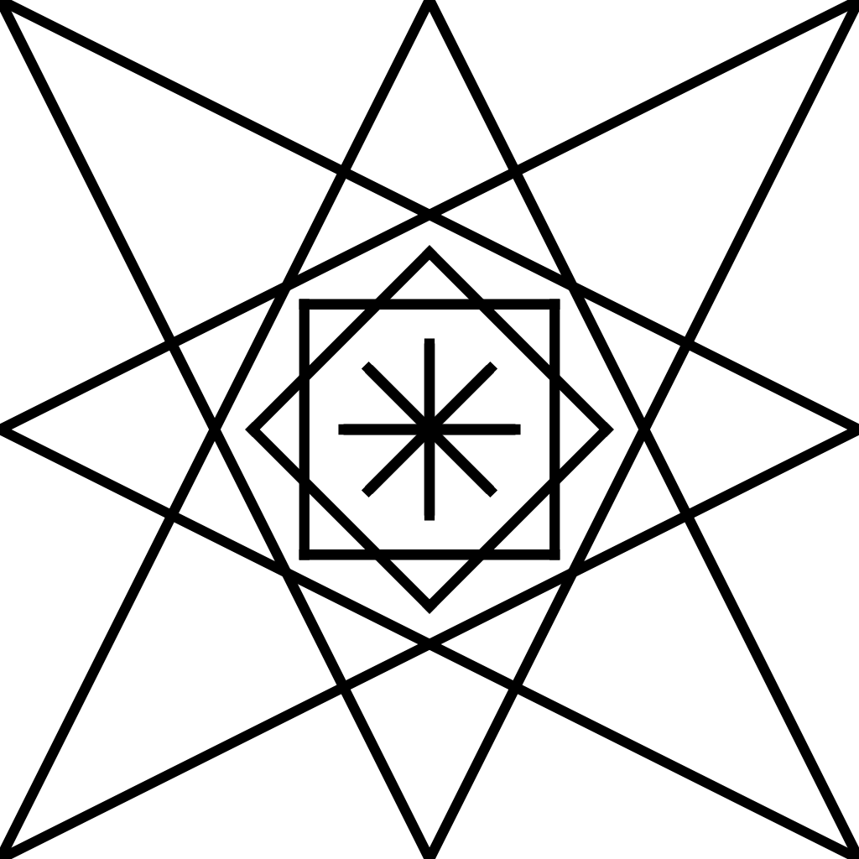
Body
The Body was expected to be a normal 5 pointed star, but becomes excessively large when drawn around the Mind Star. Especially since a 5 pointed star naturally aligns with the shape of the human body and its limbs.

It ought to represent the 5 senses and a state of input, output, both, or N/A. Additionally it ought to have a way to decipher represent different forms of things like touch (e.g., feeling hot, cold, pain, pleasure, pressure,etc.)

It ought to also represent states of the body like sexual arousal, hunger, fatigue, sickness, etc.
Part Three
Vampirism

Vampirism
When it comes to complex psychology, it can be useful (and more fun) to speak in terms of metaphors and archetypes. An archetype is a set of psychological traits common to everyone in such a way that these traits repeat in different communities across different cultures and time periods. An archetype always points to something within the mind, while a metaphor tends to extend outside of the mind.
The primary archetype I focus on is the vampire. A vampire is a category of archetypes that reside in the spirit, manifested as insecurities on some level that wind up causing them to “feed on” the innocent (in various ways). It is a spectrum that is tied to the Narcissism spirit trait, but I believe everyone is or was part vampire at some point. To be afflicted with archetypal-vampirism is when insecurities of some sort (in the spirit) cause a soul to sin against the innocent as a maladaptive way to cope with insecurity. This is a spectrum of behavior, and to some it’s clinically locked in as a personality-disorder. It’s like playing a cooperative game with a player that is stuck in competitive mode, they only know how to cooperate as a front for competitive strategy. This often doesn’t pan out well in “cooperative games” like friendship or a relationship, and becomes even more complex in things like parent-child relationships where each “player” has different roles and uneven power dynamics.

There are many types of vampires but a core feature is that they lack familiarity with their Self. That feature is not vampire-specific, but all vampires seem to lack a solid and genuine connection to their Self. They do not lack a Self, but they have a poor connection to it. So they often -imitate- personality in such a way that it does not stem from their Self but is a fabrication based upon observations of others and their subjective idea of success. For this reason there is the metaphor that a vampire has no reflection in a purifying Silver Mirror. But again, not everyone who lacks a reflection is a vampire.

Vampires and Light
If we present truth to the Self, we can refer to that as “Light.” Light is truth that is appraised by the Self, it has two components (i.e., truth presented to a Self). It is light that burns away vampirism because the Self naturally appraises vampirism negatively (as sin). This same light is generally harmless to humans, and so light is the weapon of choice when fighting vampires (another word for it is Love). The goal is to remove them from abusable positions of power, find better ways to coexist, and/or find a cure. I believe most vampires would prefer to be cured & know -real- Love. No vampire I have met has seemed to know any other way to think and interact with the world, and all of their behaviors seemed explainable by their upbringing. Vampires are victims (that’s how they’re made) and become victims of their own minds as a result. They seem to do the best they know how to do, and wind up very skilled in doing the wrong things.

There are concepts like Groupthink, Group Narcissism, and Triangulation which are important to be aware of when dealing with everyday vampires. In any case the goal is to shine light on vampiric influence in such a manner that is also considerate of how you come off to others. It is generally easiest and most polite to call out vampirism after you have been bitten, and that is why my early strategy relied on the (ethical) use of bait.

The bait for most vampires is your own blood, which is metaphorical of cringe, the-ick, misfortune, or whatever ways a vampire might enjoy “biting” you. If they have shame about feeling like a “loser,” you ought to appear like one who’s confident and could be knocked down a peg. If they have shame about feeling “stupid” you ought to come off simple minded in some way. To bait a vampire effectively you need to really know their psychology well as a sort of 6th sense to perceive the-ick how they do.
However using bait is an outdated strategy that can and will bring unexpected trouble your way. Instead it’s important to know -how- to bait and develop that 6th sense to detect their “hunger” purely for identification purposes. Always bait ethically, and always be the most morally virtuous you can be. The end goal is to shine light on a vampire and a victim. This is usually to combat their subversive influence on a group you are both mutually a part of, so you present the truth to the Self of the group. But sometimes this can be done to present truth to your Self, and burn away a vampire’s influence on your mind (e.g., undue trust).

There are Daywalkers (overt), Nightwalkers (covert), and a few more archetypes. For example, Werewolves are hurt & mistrustful people that -can- bite like vampires but generally don’t bite the innocent, and they bite for different psychological reasons. They aren’t as avoidant of sunlight, and do have reflections. Everyone is part werewolf in my opinion, just like we all are or have been part vampire on some level. The first vampire one ought to hunt is the vampire in their own head. Think of the last time you made fun of somebody or found joy in someone’s misfortune. Can you dig deep and find the -real- reason you felt the urge to do that?

On a side note, as a vampire hunter you must never lie (ever). Not even white lies. Telling nothing but truth gives your words power, and there is a hell of a lot of leeway to manipulate with nothing but the truth. It puts you at a disadvantage against liars at first but is more powerful than lying once skilled at truthing. Make your word powerful.
Truth Table
The original motivation to create this symbolism was to create a tool of truth to clear up distortions of the truth, as well as conquer communication barriers. All for the purpose of vampire hunting. The ability to prepare a well aimed shot for when opportunity to communicate is rare, and present a picture that’s worth a thousand words.

I’ve based a grid of symbols upon Neil Degrassi Tyson’s concept of Three Truths (e.g., Objective, Personal, and Political). That is the three columns.
The first row is Effect (on the soul), the second is the Perceived Other (i.e., their soul), the third row is Soul, and the fourth row is Affect (from the soul). This table might change a bit as it’s new, but it lays out and organizes various truths to any action performed by a soul toward another. Pair two of these tables together and it represents an interaction between two souls with a minimum of 24 different perspectives.

Objective truth may only be supported by factual evidence. Additional rows and columns may be added too. For example, there are often multiple subjective truths as well as multiple political truths (or audiences). Not every aspect needs to be filled out, it ought to be used to highlight the important details of an interaction without ambiguity.

Many forms of vampiric manipulation rely on obscurity and hiding truth, so this table aims to communicate complex truths to the Self of one or more people. Each truth is symbolically written in the language of the soul and gains the psychological perks of an “I Feel” statement. The Subjective columns are always valid and everyone may say their piece there.

Objective Subjective Political
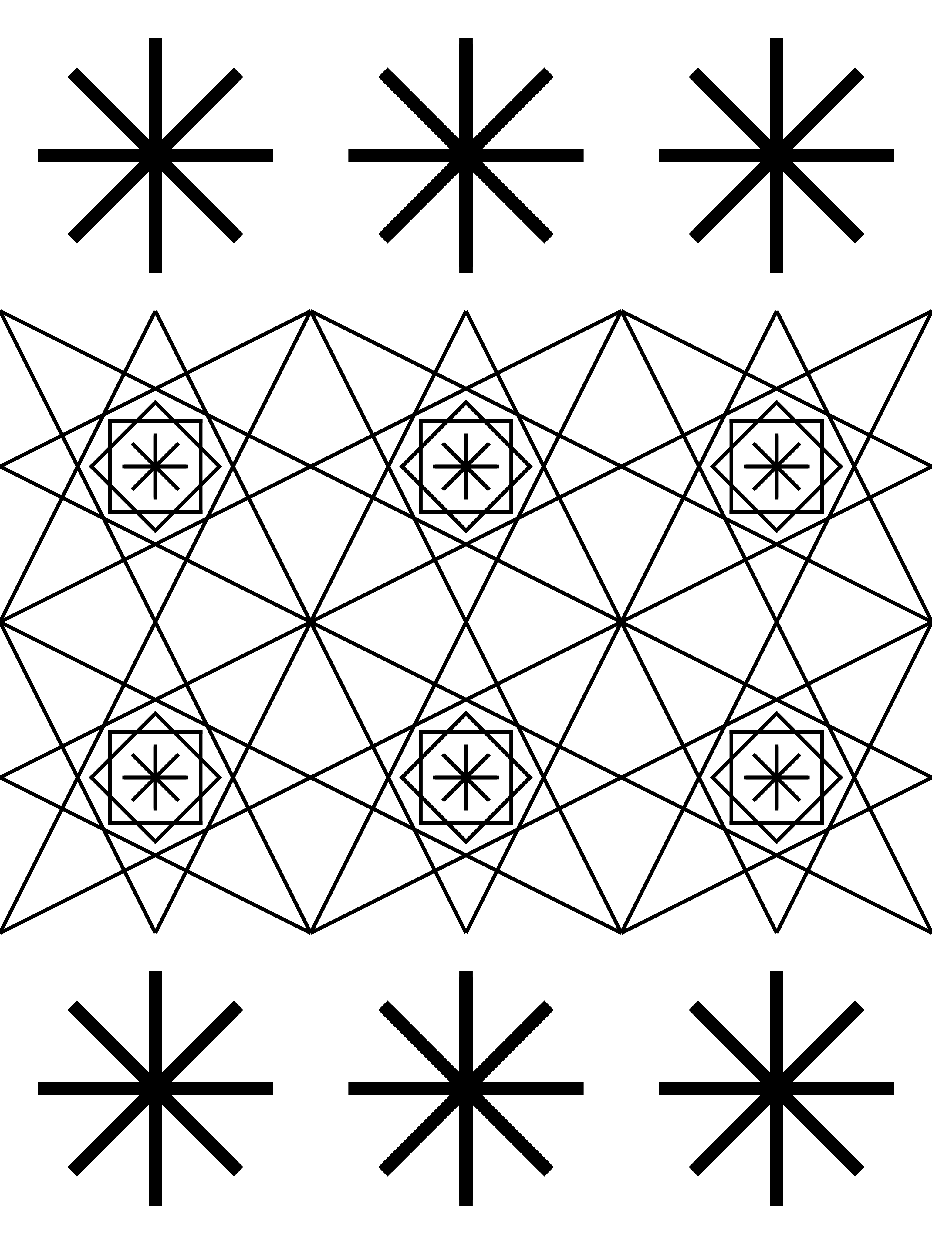
Truth Truth Truth

The Sword of Truth
This truth table is intended to be the successor to all of my vampire hunting tactics. It needs no bait, you don’t need to wait to be “bitten” first, nor juggle a billion possible realities in your head as you watch moves get made. So much truth can get revealed in one fell swoop and save time. Gone are the days of vampire hunting with blood and sunlight, we got a sword now.

With this truth table being metaphorical of a sword, the focus turns to swordsmanship. We don’t think in terms of symbols and truth-tables but it is a structured way to communicate and organize those thoughts. It also attenuates speech of people who either don’t have the words to communicate their feelings, or have tendencies toward “biting words.” Each “jab” of the sword is an “I Feel” statement and perception. This can be done in picture form or as words, but the table is there to help organize thoughts when words fail.

The goal of “vampire hunting” isn’t to drive a metaphorical stake through their heart or torch someone’s soul to ashes in the sunlight. But to find a cure (for their sake and others’), find better ways to coexist (minimize harm), and keep them from feeding upon the innocent. Agape Love includes love for vampires as well as victims of vampirism.
The Gentle Jab
As of now I’ve only used this “sword” once, and it was a precision jab (in word form) straight down to the core of the soul to expose vampirism in HD before an audience. Circumstances were rushed so it wasn’t as gentle as I’d have liked nor was it the ideal move to make but did effectively become a permanent filter of truth to expose all past, present, and future vampiric manipulations of political truth. I stopped short of exposing the underlying mechanism of their vampirism because that is more vulnerable and might even shatter the soul to be so psychologically exposed before others. I’ve heard it said in psychology that people generally never want to see you again if you make them feel shame, so that was a flaw of this approach. It was highly effective in addressing the vampirism but at a great psychological expense of the one afflicted by vampirism.

The biggest psychological obstacle to me seems to be Shame because people generally don’t like to have that exposed within their soul if they spend their life hiding from and coping around internalized shame. I believe was the 2nd buddha that said you can’t destroy pride (which masks shame) without shattering the soul too, so to give pride something better to be prideful about. I can’t help but wonder if this sword could be used to metaphorically cure vampirism in that manner. This would have to mean presenting someone afflicted with vampirism a clear and precise description of -how- their vampirism works, and how it “ought” to be instead (recall Humes’ Guillotine). It might be unrealistic but the Self of the vampire would be used as the light that burns their own vampirism away, while a clear and detailed understanding of how they “ought” to be (and can be) is offered. Fear would likely be experienced (as shame) when confronting themself, and fear turns to -trauma- when we lack the means to handle the situation. In other words they need to learn a new way to exist before they can let go of the old (in theory). I could be wrong.

The kiss from the Phantom of the Opera comes to mind. Like showing them how to fix that big gaping empty hole they feel inside (and pretend isn’t there), and show them how to begin to experience that thing all the others seem to have but they don’t. Teaching someone to hunt the vampire within themself and become more human. They are victims of themselves too, and professionals at coping -around- it. It seems to be all they know.

I imagine I get how they feel when it comes to being honest with yourself about human connection. I’ve experienced many imitations and substitutes for human connection (without knowing better) and it’s taken me a long while to decipher what it “ought” to be (Love). So now I know what I’m missing at least, and have a sense of direction in how to find it.
It’s a bit more personal but a current goal of mine is to experience a hug like I see many people enjoy without a thought. I can’t say I’ve ever had a real one, not platonically anyway. I aim to make it actually mean something so it will -feel- how it looks (they feel empty and mechanical as of now). To do that I need to learn to connect and blend spirits (or that’s the strategy).
But before a vampire gets to that step where I’m at, they would need to be cured of vampirism and connect with their Self so they can authentically share themselves (and finally experience human connection). Perhaps this is unrealistic or even foolish but it’s worth trying. That is the gentlest way I can think of using the sword, like a precision jab to cut out the vampirism and guide the way in its absence, without harming the soul. It would seem much easier to destroy souls than surgically heal them.

Hacks and Slashes
This metaphorical “sword” has many other potential uses and could be used anywhere grievances exist in order to communicate truths surrounding notable events.

People can learn the symbology and state the subjective truths of their Self, then work through things to decipher objective truth. In a group with a lot of history to sift through, this could conceivably be used to cut the bullshit, clear up misunderstandings, and even jab each others’ egos to pieces if desired. Each person would have a source of input (i.e., grievance or perception) on how the others’ Spirit has affected someone.

I’m yet to see the sword used in table-form, or used by others in general. In fact I’ve not used it myself much at all yet. But the philosophy is pretty solid and it must be put in writing for others to understand before anyone can test it out.

Unless someone is well versed in psychology, I would only expect them to know how to use it to state their feelings as a source of Self appraisal (attenuated by the sword/table). When just starting out, people need to put in words why they drew the symbols they did. This would clarify intended meaning matches the interpreted symbol. It’s all a work in progress.
Collective Entities
There is a new (to me) type of vampire I have come across which is much trickier to talk about. It’s has an extreme level of resources and other-vampires, as well as non-vampires at its disposal. An organized vampiric entity that likes to keep its identity concealed, and works primarily from the shadows.

For this it is helpful to tap into the metaphorical way of thinking that Thomas Aquinas uses when talking about supernatural entities. He refers to them as a single conscious entity that (for our purposes) physically exists through its conscious influence on multiple souls . A solid legal analogy would be an -enterprise- as defined in the RICO Act. When trying to relate this to Carl Jung’s work I wind up making up a new term “Collective Consciousness” which is a broad category in itself.
A solid Computer Science analogy for this way of thinking is the idea of a Token referring to an abstract Class (with subclasses and objects) instead of a single instance. We will borrow this metaphorical way of thinking to define the idea of a “Collective Entity.” This is intentionally a new term to have a blank slate when it comes to bias around how it sounds.

When facing vampiric activity from multiple unidentifiable sources in a way that seems coordinated, it may be useful to think of it all as an “Collective Entity.” I call this entity Dracula, but would call it an Unidentified Collective Entity when speaking about it with others (or perhaps a RICO-Enterprise in legal terms).

Dracula has shown me these behaviors:
- Trying to isolate, induce fear, peril, and paranoia.
- Minimization of evidence & working in plausibly deniable ways to make it near impossible to talk about and seek aid. It seems to be a -trap- to talk about it (you sound crazy and wind up further isolated). Even bold/public acts are subtle and disguised as random happenings that are only likely to be picked up on by an individual.
- These behaviors tend to quiet down when you begin collecting evidence and trying to (carefully) shine light on the situation to others.
- Attempts of intimidation seem to be themed after what they believe is your might fear.
- Dracula seems to aim to cause infighting and will even hijack your image (such as a controversial one) to spread fear and mistrust using your name. Like a puppet master fighting through puppets.
- Dracula seems like the false-flag type and highly resourceful when it comes to manipulation.
- Digital equipment is manipulated with a complete and total root-level of control, yet buggy and flawed (but effective) manipulation. In-person shows of presence are made on occasion, and it’s done in teams (sometimes they record).
- Dracula has complete control of Walmart’s self checkouts (indicative of remote access) as well as OS-Level control of FedEx’s digital scanners (also remote access).
- Dracula has physical influence -within- companies like FedEx (where I work).
- Dracula has the capability to cut off cell phone service, and also has data-broker level access to personal info & digital history.

This Dracula is real (as a Collective Entity) and some guesses can be made about groups involved. But in theory and observation, Dracula fears the light.

It is important to connect with others to share subjective truths and stay connected. Don’t let Dracula have any control. If he threatens harm or death (on you or others), all you can (and should) do is collect evidence and secure the truth. Do not let Dracula puppeteer your actions. Document everything (make it a habit), keep each other updated regularly, and be very mindful of how you sound when talking about it.

The ALU-Card
It is difficult to know what to do when you suspect your rights are being violated by authorities and there is no solid evidence. Especially if you are isolated (like me). Even worse is if the few people you know are also isolated and potentially under the gun by Dracula as well. How many others out there might face the same scenario?

My solution is the ALU-Card. An opt-in community-bond to regularly check up on people (in-passing) through regular and non-digital exchange of notes (the card). Every day (ideally) you physically swap cards with people in-passing, usually just saying you’re ok (and maybe with a fun note). But when oppressive things happen it is where and how you can share news of that happening when you have nobody else to tell.

This is a unique solution to an ethical dilemma I’ve wondered about. It’s difficult to know how to draw the line between the fact that nobody owes anyone anything, and the other fact that we all have deficiency needs that rely on others to be fulfilled. The ALU-Card offers a community-bond focused on ensuring needs are met through an opt-in community bond of mutual service. This doesn’t have to be explicitly to fight Dracula, and it really ought to be a fun self-motivating thing like passing notes in class. Notes are saved or destroyed but kept offline and secret.
The main goal of this idea is to keep people united. You are checking to make sure they’re Alright, Loved, and United (with others). Someone is Alright if their basic survival and security needs are met. Someone is Loved if they (in general) don’t feel lonely and have their social needs met. Someone is United if they have secure and trusted ways to spread their truth (nondigitally) if needed.

This doesn’t directly stop oppressive action but it begins to network truth (amplifying light) and foster regular microdoses of in-person connection where critical information may be shared if needed. The idea is to build a -community bond- of inclusion into a network that checks up on eachother and raises awareness. This can be thought of as opting-in to the influence of a Collective Entity we’ll call Alucard. Where asking for help does not deviate from daily routine, and asking for help occurs in an instant.

When someone asks for help through an ALU-Card they will share what’s going on (subjective truth) and any evidence they have (objective truth). They can indicate whether or not they’d like aid sent their way (or if the situation is too sensitive), although this must be realistic.

If there were a decent sized ALU-Card community, there ought to be at least one trusted Alucard-Center where all ALU-Cards are sent to be compared and coordinated. This could be a small network of friends & coworkers, or something city wide. A grassroots network built on the best judgment of those involved.

Any ALU-Card community ought to have vamprie hunters if possible.
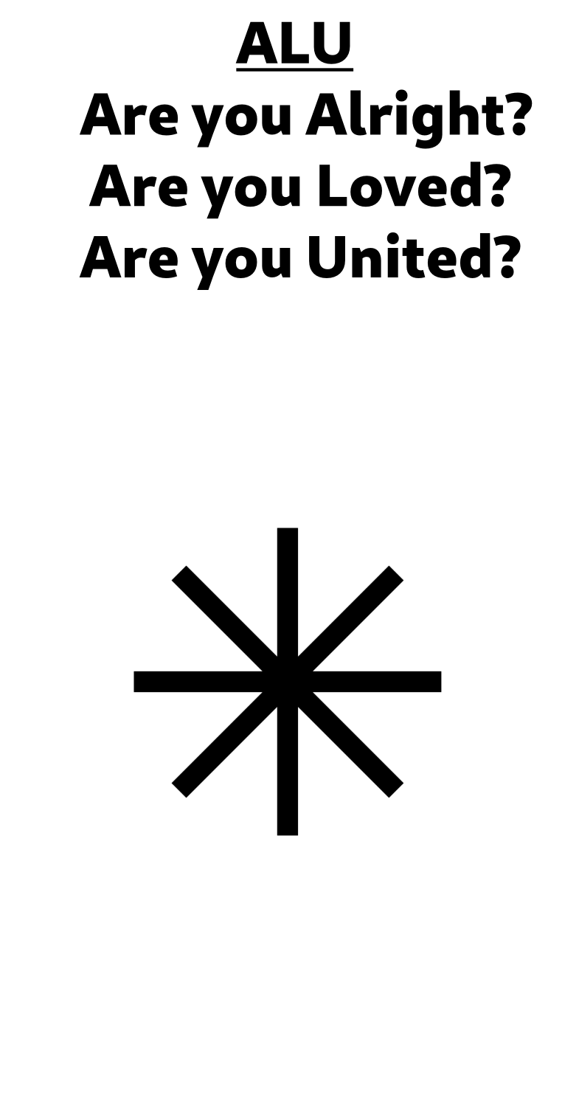
This is a quick example design of an ALU-Card. The real thing might just be a scrap of paper or even written on ones’ palm to flash at someone in passing.

If someone were not alright they could X out the A in ALU. Or if someone experienced a complex form of oppression they might put it in writing or use symbolism to help describe it. Whatever works best. Evidence ought to be supplied with it.

If someone were not loved they could X out the L in ALU. A response to this becomes difficult because not many people seem to know much about love aside from their subjective experiences. That is a major reason why I’ve began trying to pin it down in this booklet so that we can define our needs, the types of bonds we have, and have a solid idea of what is and is not in each of our social bonds. It’s hard to effectively find human connection when you don’t know what’s missing. It’s not realistic to expect others to know how to help, be able to help, or be willing to help. But it can at least make the fact known and give better odds, especially if there were an Alucard center that had a bit more know-how.

If someone were not United, the ALU-Card offers a solution. Many people are already united with friends and family but the ALU-Card offers an impersonal form of connection that strengthens community. The logistics of -how- that network connects and passes along information might be flexible but there -ought- to be regular interactions where a small or large amount of information can be shared in-person with or without a need. It’d be nice if a large network knew who was and wasn’t a part of their network. Ideally people are united in this way -before -they are in need of being united.

There is also the subject of sensitive-information which can cause damage if handled poorly. A network ought to keep in mind how to handle such information.
Notes
- The symbol on the title page of this chapter is a representation of Jungian Individuation, paired with Consummate Love (based upon Triangular Love Theory) in an empathetic form of compersion. This is the most ideal state of a “soul” that I can currently imagine.
- “… Because the existence of the soul has resisted empirical verification, science has generally ignored the concept, and those who adhere to materialism, positivism, or reductionism reject it absolutely ...” (n.d.).
References
American Psychological Association. (n.d.). Soul. In APA dictionary of psychology. Retrieved January 18, 2026, from https://dictionary.apa.org/soul

